**Convection Currents Activity**

**Aim:** To investigate the effect of temperature on the density of liquids.

**Equipment:**

* Two identical small, wide-mouthed jars (baby food jars are perfect)
* Kettle (for hot water)
* Cold water
* Food colouring (two colours, preferably red and blue)
* Card to fit over the mouth of the jar
* Scissors
* A large, shallow baking pan (if you don't have one, do this activity in the sink--it can be messy)
* A helper

*If you don't have any baby food jars you can try conducting the experiment using two identical small, clear, drinking glasses. You just have to make sure that the mouths of the glasses match up perfectly, without a leak.*

**Method:**

1. Fill one of the jars with hot water from the kettle. Add a few drops of red food colouring.
   1. What happens to the drop of food colouring?

Watch for a minute, then put the red jar into the baking pan.

1. Fill the other jar with cold water. Add a few drops of blue food colouring.
   1. What happens to that drop of food colouring?
2. Slowly add more cold water until you see a bulge of water over the rim of the cold water jar.

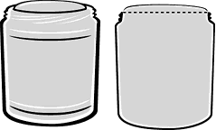

1. Lay the square card carefully onto the top of the cold water jar. Tap the card gently with   
   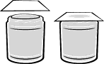your finger. (Don't poke it. You  
     
   want the card to be flat and   
     
   form a seal with the water and   
     
   the jar.)
2. 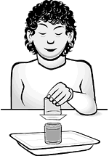This part is tricky. You may want to practice it a few times over the sink with a jar of plain water. Pick up the cold water jar and turn it straight upside-down. You don't need to put your hand on the card. The water will hold the card in place. (Just flip the jar over. Don't hesitate. If the jar is tilted but not turned over completely, the water will gush out and make a mess.)
3. Put the upside-down blue jar right on top of the red jar.

1. Have someone hold onto both jars while you very slowly and carefully pull the card out.
   1. 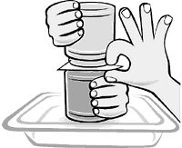What happens?
   2. What colour is the water in the top jar?
   3. What colour is the water in the bottom jar?
2. Empty both jars. Rinse them.
3. Repeat steps 1 through 6, but this time, put the jar with the blue-coloured cold water in the baking pan and put the card on top of the jar with the red-coloured hot water. Turn the red jar upside-down and put it on top of the blue jar.
4. Slowly pull out the index card.
   1. What happens?
   2. What colour is the water in the top jar?
   3. What colour is the water in the bottom jar?

**Why does the water mix so quickly when the glass of hot water is on the bottom?** Liquids that float on top of each other, such as oil and water, or ethanol and oil, have different densities her liquids. Oil floats on water and ethanol floats on oil. Whenever two liquids that don't mix are put in the same container, the liquid that is less dense will float on top of the denser liquid. A drop of oil weighs less than a drop of water the same size. The oil is less dense than the water, so it rises to the top. 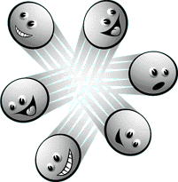  
   
When water is heated, the water molecules start moving around faster and faster. They bounce off each other and move farther apart. Because there's more space between the molecules, a volume of hot water has fewer molecules in it and weighs a little bit less than the same volume of cold water. So hot water is less dense than cold water. When you put the two together with the hot water on the bottom, the hot water rises to the top, mixing with the cold water along the way and creating purple water.

**Questions:**

1. Why doesn't the water mix when the hot water is on top?
2. Which colour water has a higher density, the blue or the red? Explain why.
3. What will happen to the water in the jars when left to settle to room temperature? What colour will it be?
4. How does the movement of the water relate to the movement of magma in the Earth’s mantle? Explain using a diagram to support your answer.